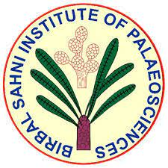
Proforma for Permission for Scientific Collaboration(s)
बीरबल साहनी पुराविज्ञान संस्थान, लखनऊ
(An Autonomous Institute under Department of Science & Technology,Government of India) 53,UNIVERSITY ROAD, LUCKNOW 226 007, UP

1. Project Summary:

2. Main Objectives:

3. Active period of collaboration:

4. Summary of roles, responsibilities for all Investigators
4.1) Investigator (s) within BSIP:

4.2) Investigator(s) of other organization(s)/institute(s).

5. Expected Outcome of the proposal:

6. Benefit(s) to BSIP in terms of human resource generation, financial assistance, equipment(s), research publication, patents or any other (please specify)

(Kindly fill this proforma along with your application for the permission of the Scientific Collaboration(s). Also, pls email the soft copy at collaborationbsip@bsip.res.in ).

